Roger Fielding BSc MPhil PGCE MEd MBA CPCC ACC

28, Low Mill, Mill Fold, Ilkley, West Yorkshire, LS29 0SY

07850 343 905
Roger@RogerFieldingConsulting.com
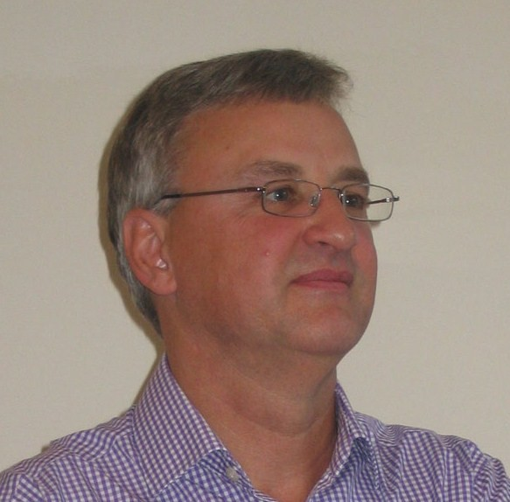

Summary

I create value for my clients by helping them get the very best from their people. I spend my time in two main ways: firstly I spend time with individual executives, directors, leaders or managers, acting as an executive co-active coach. Second, I spend time with groups, from 5 to 50 or more, facilitating Board or team meetings or organising and delivering Workshops and Away Days for strategy formulation and implementation
I believe in the power of coaching. Coaching can change performance; indeed, coaching can change lives. I want to make a difference. The work we each do is vital to our personal, financial, and social well being. And it needs to fit well, and with balance, into the rest of our lives. Coaching can be the spur to improved performance, increased reward, enhanced satisfaction and personal fulfilment. Coaching can be the key to unlocking the best that a person can be. I work with my clients to challenge the taken-for-granted, supporting them to make conscious choices, and challenge them to consider alternative possibilities. My clients are supported in finding their own best answer.

I have been doing this for more than 20 years, working extensively around the UK, and also in Ireland, Italy, Germany, France, Netherlands, Spain, Sweden, Finland, India, Hungary, Romania and Turkey. I have studied to graduate and postgraduate levels in management, psychology, education, organisational behaviour, social research and business (BSc MPhil PGCE MEd MBA). I am a Certified Professional Co-Active Coach (CPCC) accredited by The Coaches Training Institute (CTI) and an Associate Certified Coach of the International Coach Federation (ICF). I have a Diploma in Performance Coaching and a Certificate in Life Coaching. I am accredited to use Myers Briggs Personality Type Indicator (MBTI).
I work with national, international and smaller regional clients within the private, educational, cultural and not-for-profit sectors. My clients have included BT, Yell, Jones Lang LaSalle, Carter Jonas, Atkins, Persimmon, nationalgrid, McCain, Smith and Nephew, Flowserve, Rolls Royce, Portakabin, talkbackTHAMES, Braqdford Health Authority, The Joseph Rowntree Foundation, The Wellcome Trust, Mencap, Manchester University, Imperial College London, Leeds University and others

I am a Trustee and Director of Sibs, a small national UK charity supporting the brothers and sisters of disabled children and adults. See http://www.sibs.org.uk/

For more details including endorsements, please see: http://uk.linkedin.com/in/rogerfielding

Career History

April 2009 - Roger Fielding Consulting Limited

I left Mercuri Urval as a result of the severe cost reductions required by the Mercuri Urval Group from all its Group companies following the financial pressures and difficulties faced in the wake of the credit crisis and recession of 2009.

I now work independently with my clients in all areas outlined above, including executive coaching, behaviour change training, and management and leadership development.

1987- 2009 Mercuri Urval Ltd
1987 - 1989 Consultant, North West Region Manchester office
1989 - 2004 Regional Manager, Yorkshire Leeds office
2004 - 2009 Senior Consultant, UK Home-based

Mercuri Urval is an international recruitment and management consultancy which had over 80 offices in 22 countries and which specialised in the recruitment, selection and development of business leaders, key executives and managers.

Sectors in which I worked included manufacturing, renewable energy, not-for-profit, higher education, and healthcare with organisations at various stages of their life cycle

In the 22 years I worked with Mercuri Urval I opened and managed their offices in Yorkshire, and subsequently took wider responsibilities across the North and then across the UK. I was responsible for business development, client relationship management and contributions to both National Accounts and international client projects. I was latterly asked to lead the introduction and development of their coaching proposition across the UK.

From 2004 I was working primarily from home and travelling the UK on various assignments spanning recruitment, coaching, capability review, leadership development, outplacement, facilitation and training. Longevity of client relationships suggests high levels of client satisfaction.

Personal highlights include working in Central and Eastern Europe on a client customer engagement assignment and KAM coaching activity in Budapest, Bucharest and Istanbul restructuring the client's sales organisation for closer and more effective customer relationships and working in India with a client due diligence assignment reviewing existing management team capability to underpin the successful operational and cultural integration of the target Indian company. Closer to home, recruiting, developing and managing my team of ten consultants in the Yorkshire (Leeds) office was an enduring, stimulating and highly enjoyable challenge creating sustainable and profitable revenue streams for Mercuri Urval UK during that 15 year period.

Early Career

1979 – 1987 Walsall Education Authority
1979-1981 Teacher of Sociology Alumwell School
1981-1983 Head of Commerce Alumwell School
1983-1987 Head of Business Studies Barr Beacon School

During this early career period, which I very much enjoyed, I revised and rewrote the third edition of Macmillan Education’s best selling school textbook “Sociology” for GCSE students, contributed to a number of books on business and enterprise education, wrote an educational computer game for Longman Micro Software (Education) and presented at numerous training and professional development seminars and course.

Education and Professional Development

BSc
Behavioural Sciences – Psychology, Management, Sociology, Economics (2.1)
Aston University (1975)

PGCE
Postgraduate Certificate in Education - Economics and Social Sciences (Distinction);
Birmingham University (1979)

MPhil
Research Degree – Organisational Climate
Aston University (1981)

MEd
Masters Degree in Education – Politics and Management
Birmingham University (1988)

MBA
Masters Degree in Business Administration
Leeds University (1997)

Diploma in Performance Coaching (Business).
Newcastle College of FE (2002)

Certificate in Life Coaching.
Newcastle College of FE (2004)

Certificate in Co-Active Coaching Fundamentals
The Coaches Training Institute (2006)

Committed to Equality (C2E) Accredited Advisor and Auditor
Committed to Equality (2009)

Accredited Practitioner for MBTI Personality Type Indicator
OPP, Oxford (2010)

Certified Professional Co-Active Coach (CPCC)
Co-Active Coaching, The Coaches Training Institute (2012)

Associate Certified Coach (ACC)

International Coach Federation

